The Waterdeep Post

# MUSEUM ARTIFACT STOLEN

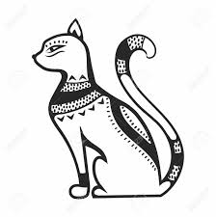

*By Thimble Smallfoot*

The new Onyx Feline Statue on display at the Baldur's Gate Museum of Antiquities has been stolen! The exhibit is on loan from the Chult Museum of History in Waterdeep and the relic is believed to be from the fabled, Hidden Shrine of Tamoachan. The statue was found in the jungles of Chult on an aged corpse among other artifacts, some displaying the symbol of Zotzilaha, a vampire god of the underworld, whom the shrine is thought to be dedicated to.

Officials are baffled as the security detail was twenty strong the night of the theft and they place a locked cage around their priceless exhibits once the museum closes.  According to anonymous sources inside the museum, the cage door was open, and the lock was laying on the ground, meaning the thief (or thieves) had the ability to unlock this incredibly tough mechanical lock. The renowned locksmith of Waterdeep, Kantelleki Tavartarr, was quoted in saying about the cage and lock, “the person who cracked this cage had incredible skill, magic, or used incredible devices as this system is among the best platinum can buy”.

The security detail is being questioned by the city watch and the director of security of the museum has been fired and instructed by the local constable 'not to leave town'. Currently there are no suspects or leads.

The city watch and the museum are asking anyone with knowledge of the crime to step forward, with as much as 100g to anyone who can offer information leading to an arrest.

# North Feels New Record Lows

*By Garfield Thornsbury*

Fall ended with record low temperatures around Neverwinter and the winter season isn't looking up.  The snow has started early this year with six feet having already fallen in Neverwinter proper and as much as 10 feet in the northern foothills.  Northern residents are beginning to worry that their supply of wood may not last through the winter as their wood collection during fall has been stifled by the bone chilling cold and snow.

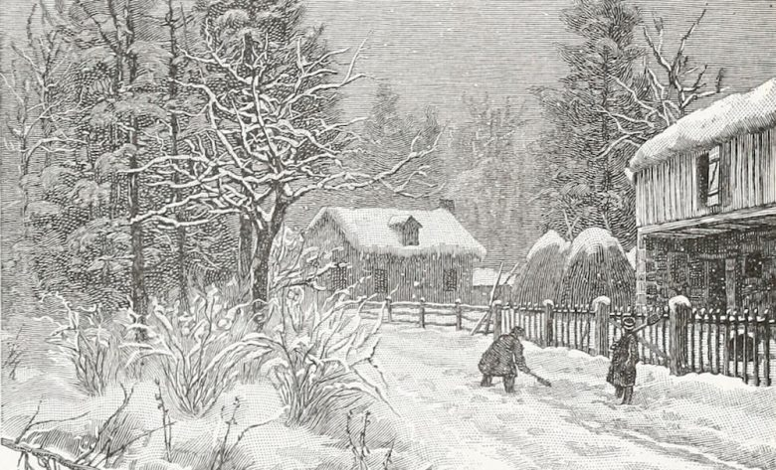

Many towns in the foothills are also worried about a food shortage as they traditionally have been able to gather some winter crops, nuts, berries, as well as trapping small game. Many residents are already having to resort to their personal supply of preserved food stuffs.

While some towns have bigger things to worry about, many townsfolk are also worried about missing their traditional winter festivals. The winter solstice is half a tenday away and towns have already started canceling preparations.  Some towns, like Longsaddle, haven't missed a year since the Spellplague (in the Year of Blue Fire, 1385 DR).  A Neverwinter official was reached for comment, only to reply by saying, "they are working with the northern townships on various solutions."

# MYSTERIOUS BEAST ATTACKS

*By Leshanna Ilphelkiir*

In addition to the frigid weather, the northern villages are seeing an increase in strange attacks from wildlife.  Unconfirmed sightings of creatures have been reported by multiple villages. These reports are compounded with the fact that an alarming number of people have gone missing.  Some of the townsfolk of Mirabar whisper about the return of Yetis after centuries of absence.

A member of the Neverwinter Lord's Alliance, Gordan Treadwell, stated that “these stories are over blown and typical rural wives’ tales” but the Alliance does acknowledge that the number of wildlife attacks is up in the area.

An anonymous source inside the Lord’s Alliance has reported that a scouting party has been sent north into the mountains to ascertain whether this threat is real. No one at the Alliance was able to be reached for comment on this matter.